**Day 6 notes | Dec 04 2024**

Unity Catalog topic

It provides centralized access control, auditing, lineage

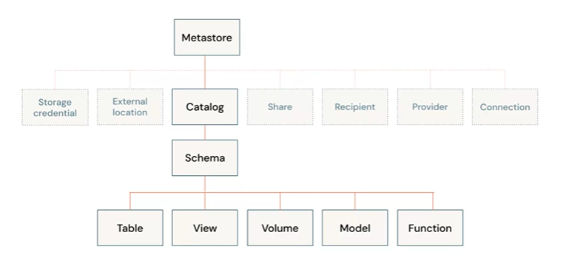

Key features:

* Define once, secure everywhere
* Standards compliant security model
* Built in auditing and lineage
* Data discovery
* System tables (Public preview)

(Catalog.schema.table) is the higher level namespace that organizes your data